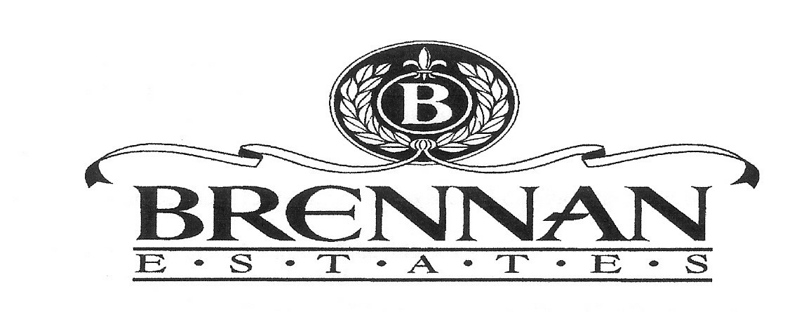
Meeting Minutes October 14th 2015
Opening:
The regular meeting of the Brennan Estates HomeOwners Maintenance Corporation was called to order at 7:04pm on October 14th 2015 in Olive B. Loss by Heather McVey.
Present:
Heather McVey Nemishh Mehta
Rose Smith Carol O'Donoghue
Zenobia Thompson Penny Wagnon
Ernie Dempsey Gerri Thomas
Earl Jaques
Guest Speakers

Earl Jaques
House School Road- Expand the road, take out crossovers. Bids are out. Construction is expected to start soon
Glasgow Avenue- Add another turn lane. Construction starts in the Spring.
Main Street behind ice cream shop (Bruster's) there will be a shopping center and professional center coming soon. Construction is set to start soon. Shell gas station leaving, Rite Aid coming soon.
301 to Summit Bridge last piece to be constructed. Requires Federal money, could take some time
Question from Resident:
The new speed sign doesn't work, when will it be fix? -Repairs are on board, doesn't know who fixes them.
Will there be solar panels on the Gazebo?
-Yes. After new roof is put on.

A. Old Business Trash Cans

New cans have been installed. Get 2 at the basketball court area.

Front Entrance
Project is complete. There are new trees, old stuff pulled, bushes are down that covered sign and the light bulb changed.
Speed Limit Signs
One solar speed sign is out. Electric issue on North and East

Playground
Project completed- Fire/arson, lit the tunnel on fire. The layout changed a bit, no tunnel just a bridge
Playground Lighting
Heather will handle- Light on the large pole is burnt out on both sides- behind pool.

Playground Mulch
Mulch is already done. Will be done again next year. Done earlier this year and gets cut back in Mid-November.

Fountains
There is an extra one in storage. There is a problem with one; The one closer to the Gazebo is slower than the other one. Gerri will call to take care of the problem.

Subsection Signs
The one going into Meadows need to be painted and repaired. Plans to paint them all is in the works. Painter will need to know what paint to use. Arbor is missing “deed restricted community”

Architectural Changes
Huge increase in solar panels. Solar panels are allowed as long as it's not connected. Changes must be submitted to committee.
Website
Plan to add to it.

Facebook
Like us on Facebook. Garage sales, babysitting, missing animals, Updates on traffic/police report. Post to get acquainted in the neigborhood.
Meadows Gazebo
Approved at a higher price. Vote on replacing

Budget Committee
Budget list-
Money for new lighting Painting of signs

B.New Business:

Meadows Gazebo Project – Delaware Power Wash Plus

Fees would include: Gazebo Repairs and Painting;
Removing all existing cedar roofing and install new cedar shake roofing (20 year shingle)
Apply clear lumber seal finish on roof
Stain concrete pad (graffiti prevention)

Replace and repair all damaged and missing wood
Prepare and paint all wood inside and outside of gazebo, with the expection of the roof underside. (no existing paint presently) Two coats using Behr Premium Paints (color provided by customer)
Apply anti graffiti coating
The repairs would be reapplied every 3-5 years Would also stain cement/concrete.
Meadows Gazebo Project for repairs and repainting voted on October 14th, 2015.
Earnest made a motion to approve. 2nd by Zenobia. All in favor!

Treasurer’s Report- Gerri
BUSINESS CHECKING
AS OF 09/30/2015
$57,958.26

REPLACEMENT OF ASSETS
AS OF 09/30/2015
$111,077.99
SUPER MONEY MARKET
AS OF 09/30/2015
$22,667.26

Checks from the County come 5 times a year – the first one being received in May.
The Financial Report is available at any time – please contact Gerri Thomas at 302.832.6170

Adjournment: The meeting was adjourned at 8:00 p.m.
The next meeting is scheduled for December 9, 2015 at 7:00 p.m. in the Olive
B. Loss Elementary School Library
Minutes submitted by: Alicia Diaz

Approved by: Heather McVey

